Table of Contents

**Features of Mongo DB2**

**Installing Mongo DB4**

**Starting Mongo DB7**

**Some Commands in Mongo DB8**

**Python Code Implementation8**

**Bonus: UI for MongoDB9**

**Working with MongoDB**

MongoDB is a document-based, general purpose, distributed database with scalability and flexibility. And most of the features are free to use.

1. **Features of MongoDB**
2. **Rich JSON Documents**

* The most natural and productive way to work with data.
* Supports arrays and nested objects as values.
* Allows for flexible and dynamic schemas.
* The document model maps to the objects in your application code, making data easy to work with.

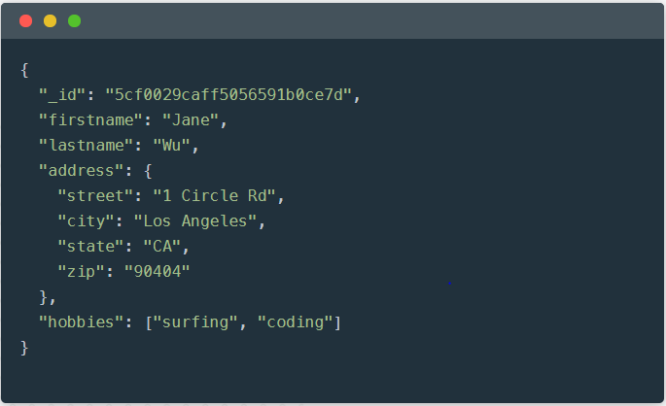

## Powerful query language

* Rich and expressive query language that allows you to filter and sort by any field, no matter how nested it may be within a document.
* Support for aggregations and other modern use-cases such as geo-based search, graph search, and text search.
* Queries are themselves JSON, and thus easily composable. No more concatenating strings to dynamically generate SQL queries.

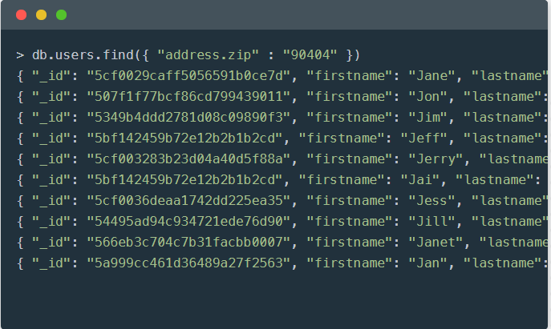

## All the power of a relational database, and more...

* Full ACID(Atomicity, Consistency, Isolation, Durability) transactions.
* Support for joins in queries.
* Two types of relationships instead of one: reference and embedded.

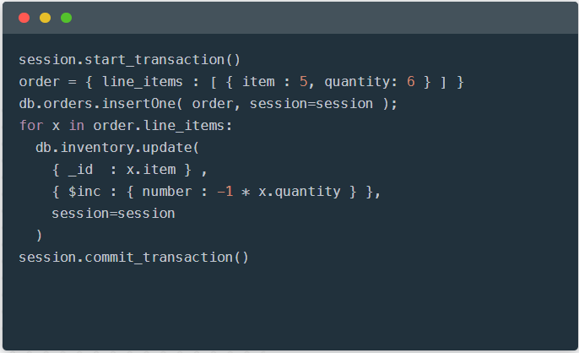

1. **Charts**

* The fastest way to create visualizations of MongoDB data.
* Built for the document model.
* Visualize live data from any of your MongoDB instances. Available on MongoDB Atlas.

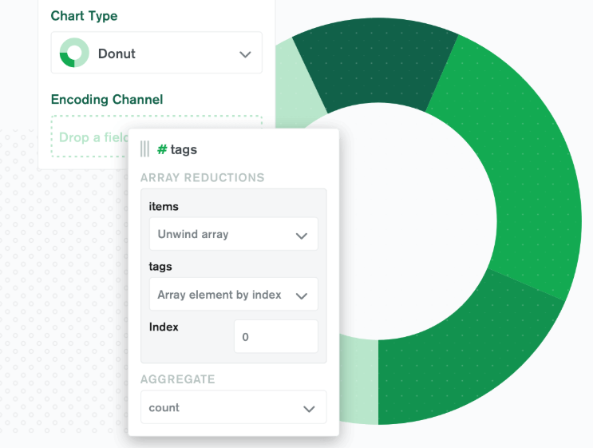

1. **BI Connector**

* Allow any BI tool that can speak the MySQL protocol to work with your MongoDB data.
* Leverage the BI tools your organization already uses.
* Perform federated analytics, combining data from MongoDB and other databases.

## Compass

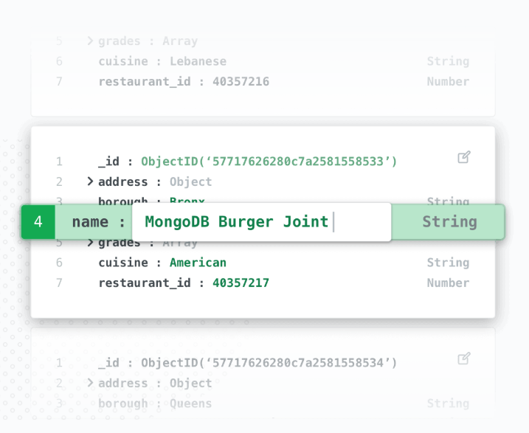

1. **Installing MongoDB**
   1. Go to the page: <https://www.mongodb.com/download-center/community> and select the MongoDB installation to download based on your operating system.

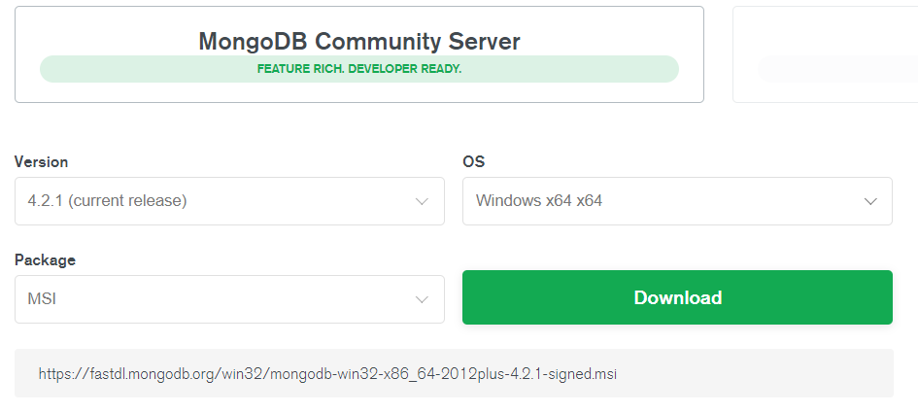

* 1. After the installer gets downloaded, double click on the installer file to start installing the application.

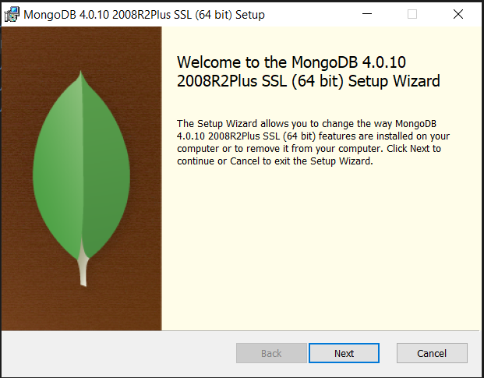

* 1. Click on the next button to move to the next step and accept the agreement.

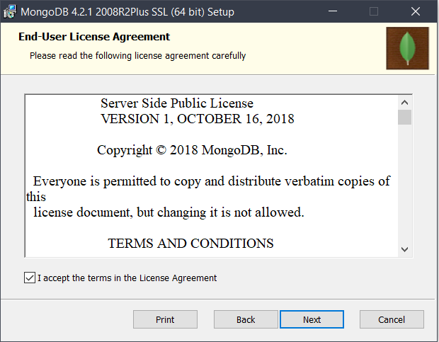

* 1. Select the type of installation:

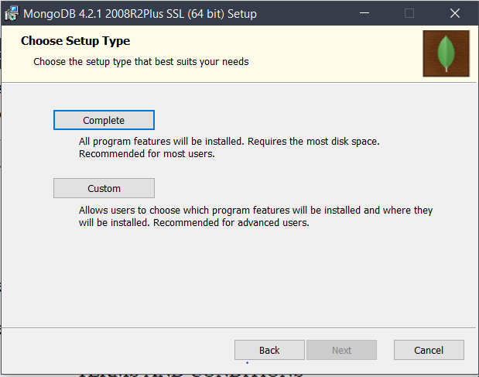

* 1. Select the features to install.

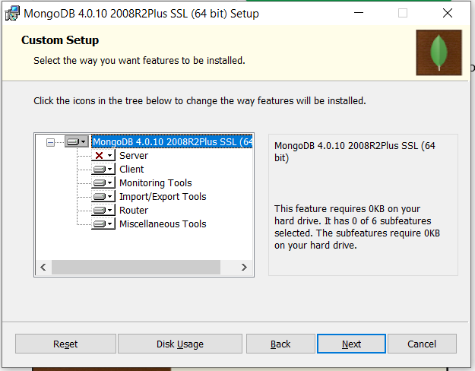

* 1. Click on next and then configure/customize the way you want the application to be installed.

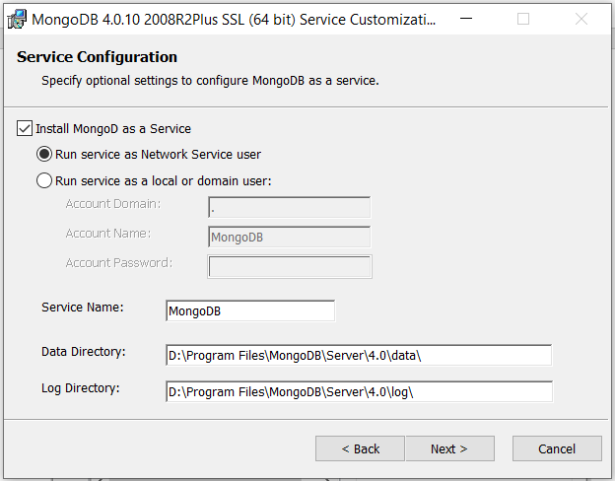

* 1. Click next and then click on install to start the MongoDB installation.

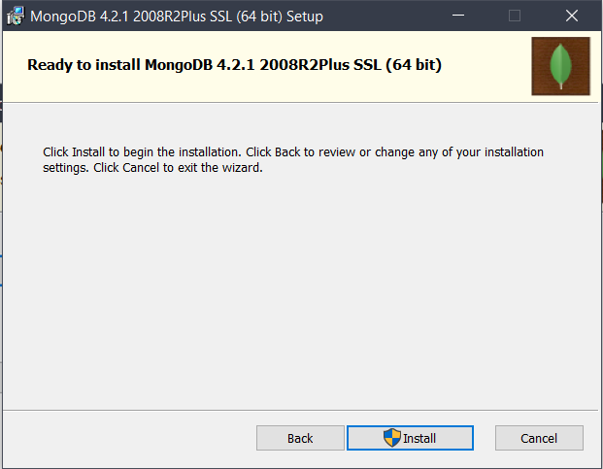

1. **Starting MongoDB:**
2. Go the services section and then start the MongoDB service if not already started.

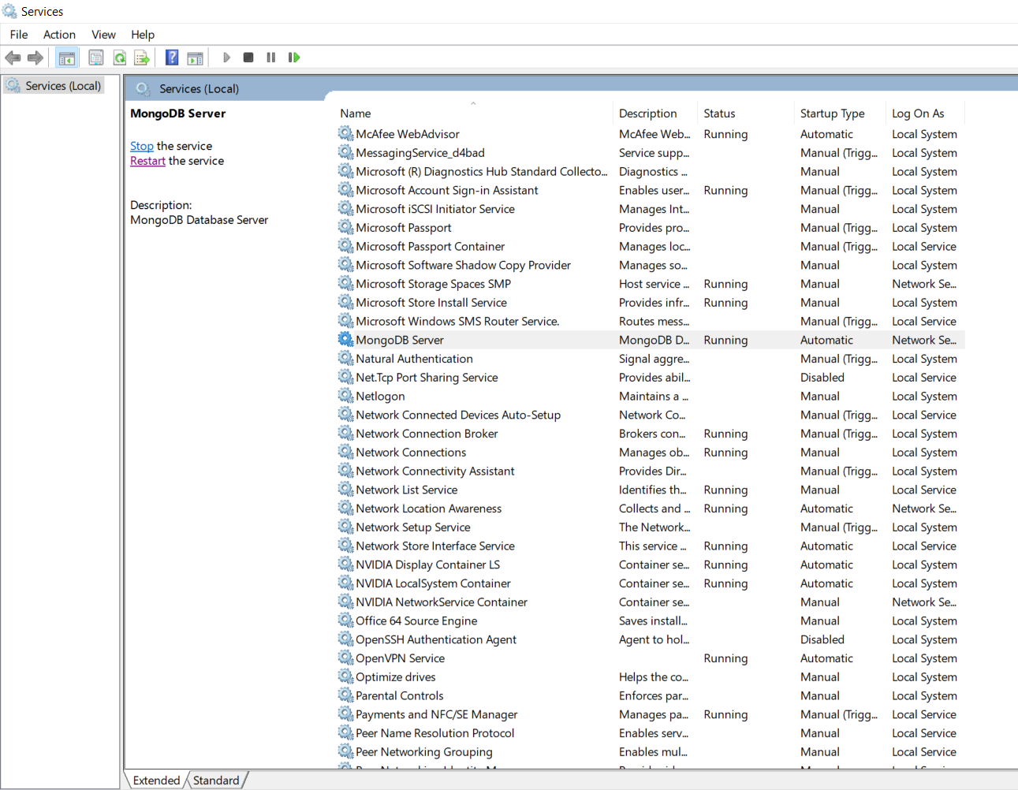

1. Now, to check whether the database server is up or not, go to the bin directory of the MongoDB installation and run the ‘mongo’ command as shown. If the command runs successfully, it means that the server is up and running and we can proceed.

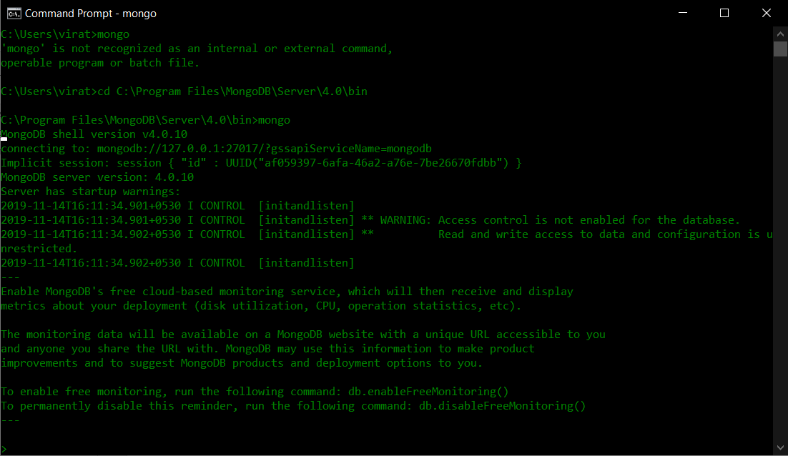

1. **Some Commands in Mongo DB:**

Different commands can be used for different purposes:

* show dbs: to show all the databases
* use <DBName>: creates a new database with the name if not already present or starts using the database given as database name.
* db.createCollection(‘<collectionName>’) : to create a new collection. Collections are analogous to tables.
* show collections to show all the collections in a database.
* db.<collectionName>.insert({“key”:”value”}) : to insert new record into the table.
* db.<collectionName>.find(): To show all the records from a table.
* db.<collectionName>.update({“key”:”value”}, ({“key”:”new_value”}) : to update an existing record in the table.
* db.<collectionName>.remove({“key”:”value”}) : to remove record(s) from the table matching the criteria.

1. **Python Code Implementation:**

import pymongo # package which enables us to connect to the MongoDB

dbConn = pymongo.MongoClient("mongodb://localhost:27017/") # connecting to the locally running MongoDB Instance

db = dbConn['crawlerDB'] # connecting to the databse named crawlerDB present in the mongoDB

mydict = {"Product": "samsung", "Name": "testName", "Rating": '3'} # creating key value pairs for inserting into the DB

collection=db['samsung'] # obtaining the collection name

x = collection.insert_one(mydict) # inserting record into the collection

reviews= collection.find({}) # Finding all the records in the collection named Samsung

for review in reviews:

print("product: "+review['Product']+", "+"Name: "+review['Name']+", "+"Rating: "+review['Rating'])

Output:

product: samsung, Name: Karishma Barah, Rating: 5

product: samsung, Name: Amritlal Baraia, Rating: 4

product: samsung, Name: Roshan Kumar , Rating: 5

product: samsung, Name: Ameya Gaandhe, Rating: 5

product: samsung, Name: Aryan Jadhav, Rating: 5

product: samsung, Name: Apurba Mondal, Rating: 5

product: samsung, Name: Sourav, Rating: 5

product: samsung, Name: Flipkart Customer, Rating: 4

product: samsung, Name: Anand Jadhao, Rating: 5

product: samsung, Name: ANKIT CHOUKSEY, Rating: 5

product: samsung, Name: No Name, Rating: No Rating

product: samsung, Name: testName, Rating: 3

1. **Bonus: UI for MongoDB**

If all these black screens(Command Line Interfaces) scare you, then MongoDB has an application called MongoDB Compass which provides a user interface where the databases and corresponding collections can be viewed. It also shows the performance of the database server.

You just have to download the MongoDB compass installation file and proceed with the installation as we did for MongoDB server.

* Once the application gets installed, you can run it and connect to the already running database server as shown below:

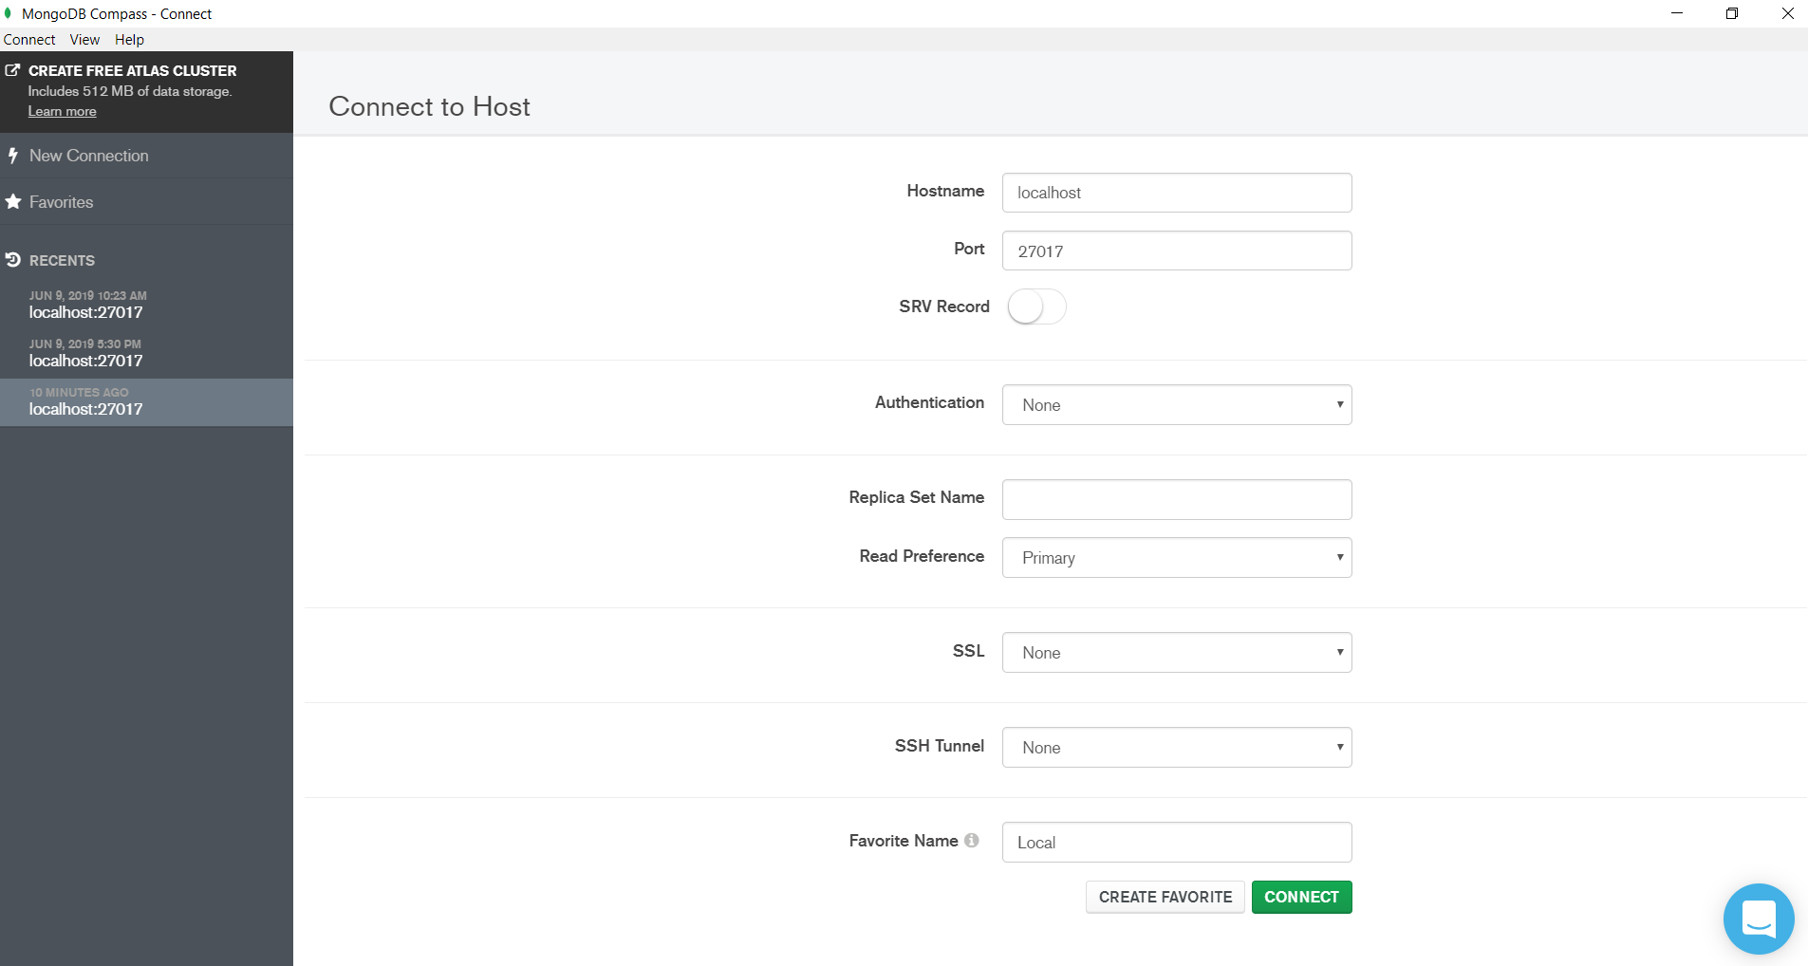

* Once you click on connect, it will show the following details:

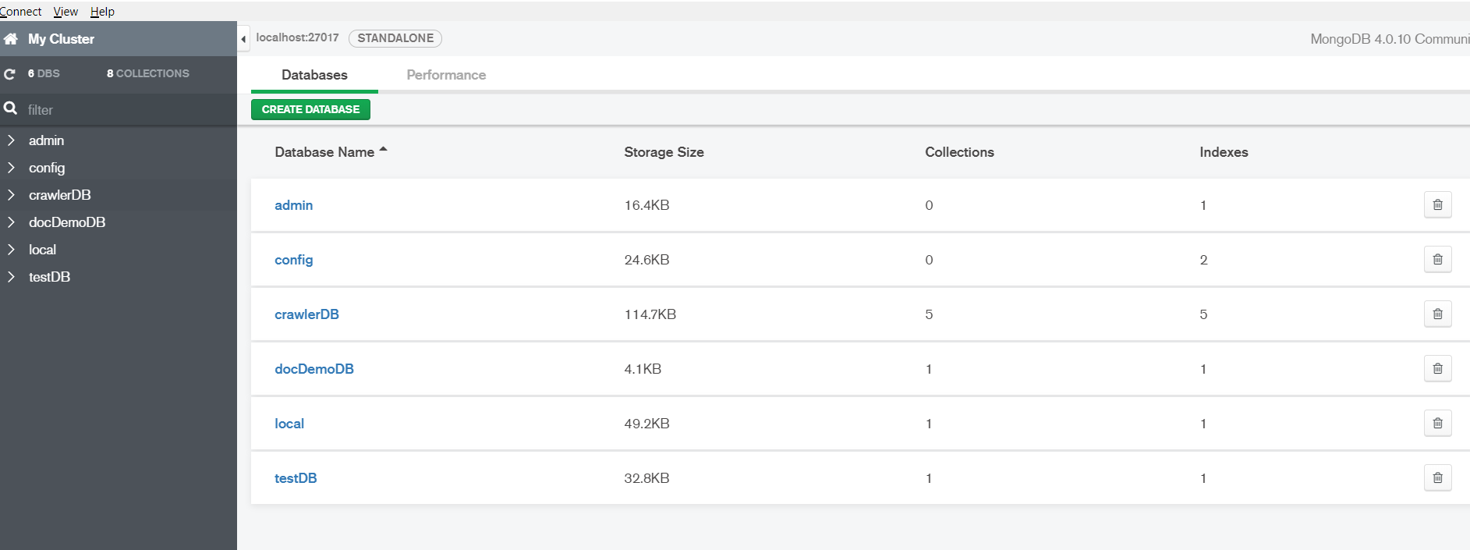

* Here, you can select the individual database to see the collections in that database. And similarly, a collection can be selected to see the records inside.

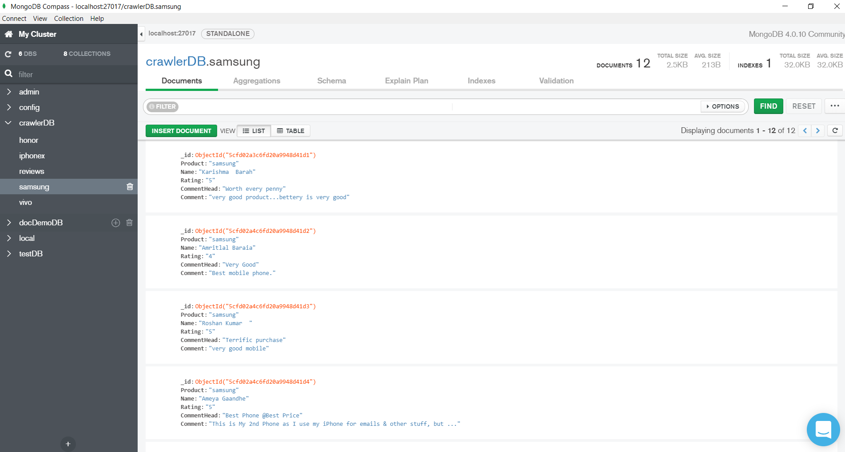

* Clicking the performance tab shows different metrics related to performance:

